Parallel and Distributed Computing

CSE4001

Fall Semester 2020-21

Lab Assignment 9

**ISHAAN OHRI**

**18BCE0265**

**Aim:**

Write a C program to use MPI_Reduce that divides the processors into the group to find the addition independently.  
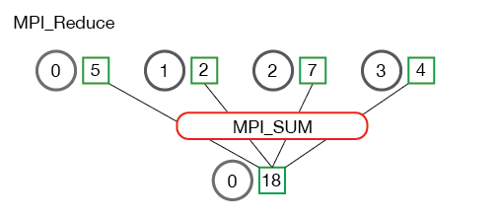

Hint. The function prototype is as follows:

MPI_Reduce(

void* send_data,

void* recv_data,

int count,

MPI_Datatype datatype,

MPI_Op op,

int root,

MPI_Comm communicator)

**Source Code:**

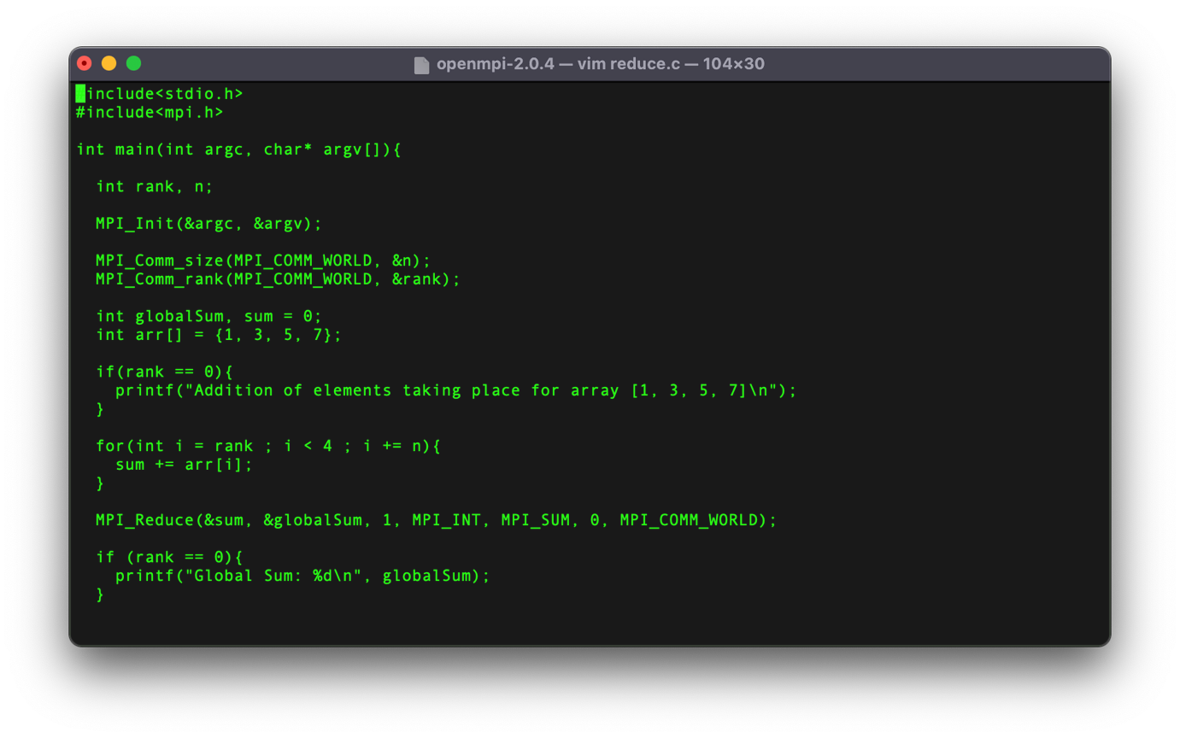**Execution:**

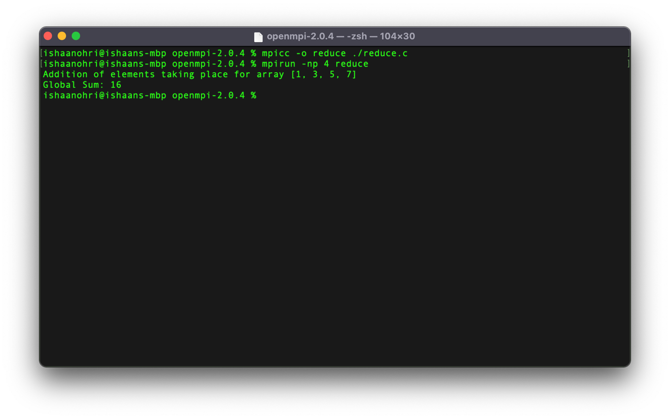

**Remarks:**

int MPI_Reduce(const void *sendbuf, void *recvbuf, int count, MPI_Datatype datatype, MPI_Op op, int root, MPI_Comm comm)

In the above command

* sendbuf is the address of send buffer
* count is the number of elements in the send buffer
* datatype is the data type of elements of send buffer
* op is the reduce operation
* root is the rank of root process
* comm is the communicator
* recvbuf is the address of the receive buffer

Using MPI_Reduce, MPI process can apply a reduction calculation. The values sent by the MPI processes will be combined using the reduction operation given and the result will be stored on the MPI process specified as root.